**Deploy PHP Application with Automation Tools (Github&Cloudways)**

|  |  |
| --- | --- |
| **Version** | 1.0.1 |
| **Prepared by** | Rimah Houssameldine |
| **Audience** | Software developers. |
| **Date** | 2024-18-2 |

**Table of Contents**

Introduction: 2

Requirements: 2

Steps for deploying PHP Application with Automation Tools (Github&Cloudways) 3

Signup & Launch Server 3

Generating SSH Keys 4

Upload SSH Key To GitHub Repository 6

Copy the SSH Address of Repository 7

Set up database 8

Deploy Code from Your Repository 9

The Server Monitor 13

Monitors on Websites and Their Logs 14

Conclusion 15

# Introduction:

Developers utilize GitHub to collaborate with numerous team members and open source contributors while developing code solutions.   
 The best feature of Git is that it allows developers to manually construct custom workflows or integrate third-party PHP deployment tools.  
 Cloudways allows you to deploy code from your application's Git repositories. This will not function unless your Git repository supports Git via SSH. For Git deployment, follow the simple steps outlined below.

# Requirements:

* PC (Desktop, Laptop)
* Git&Github.
* Account on Cloudways.
* VS Code.
* Browser and Internent

## Steps for deploying PHP Application with Automation Tools (Github&Cloudways)

### Signup & Launch Server

First, signup at Cloudways and launch your server and application. Next, move to the **Application tab**by selecting any app from application page.

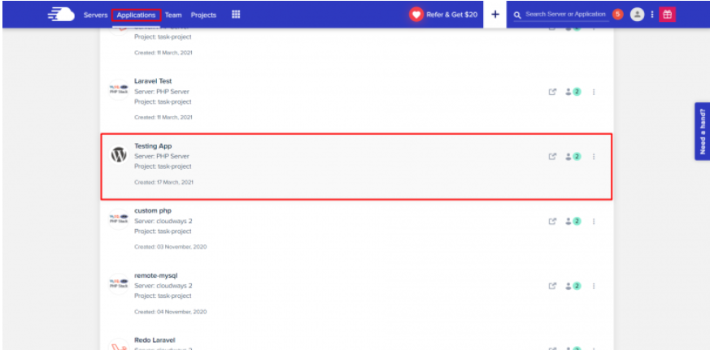

### Generating SSH Keys

Here, you must download SSH keys by moving to Deployment via Git tab,

We will use these keys to allow access from your Cloudways server to your git repository. Now click on the **Generate SSH Keys** button to generate the keys.

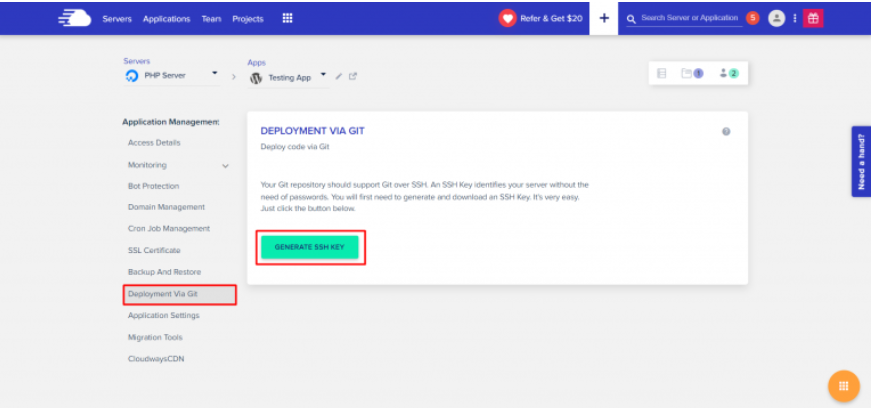

Now, click on **Download SSH Keys** to download SSH Public Key that we will use in the next step.

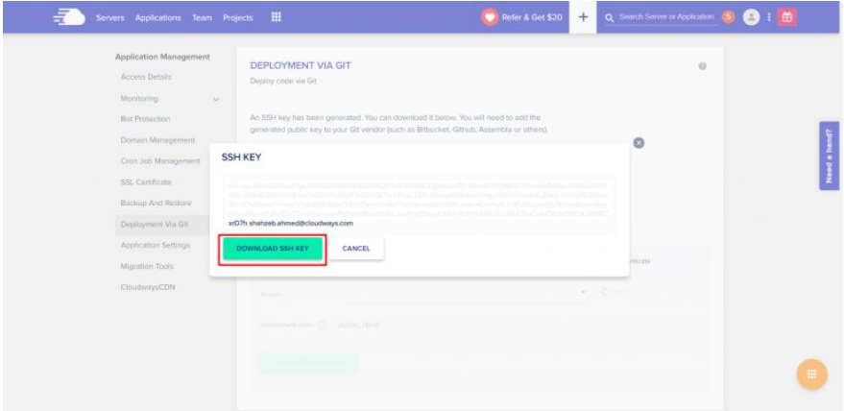

### Upload SSH Key To GitHub Repository

On Github, navigate to the repository and find the code which you want to deploy. If you are using another Git service, you will have to find the equivalent way of deploying them. Go to **Settings -> Deploy keys** and click on the **Add Deploy Key** button to add the SSH key. You can also give a name to this key in the title field and copy the key to the box. Click on the **Add Key** button to save the SSH key.

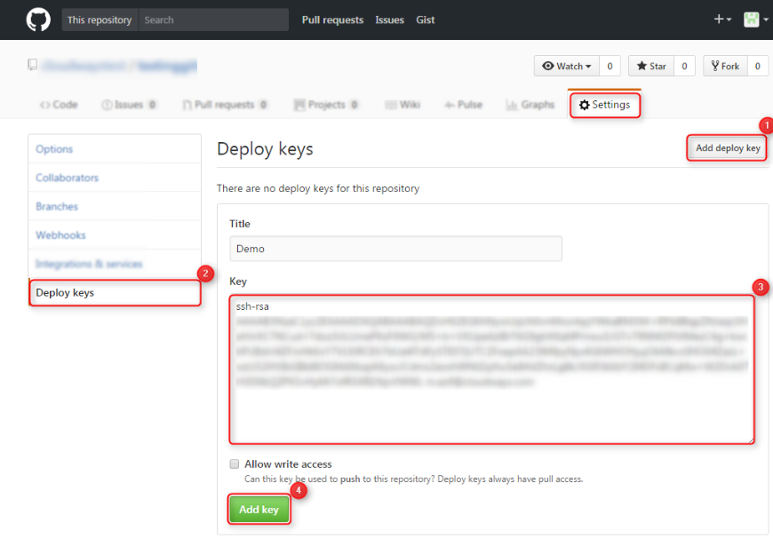

### Copy the SSH Address of Repository

Copy the **repository address** as shown in the image below. Make sure to copy the **SSH address**as other formats (like HTTPS) are not supported.

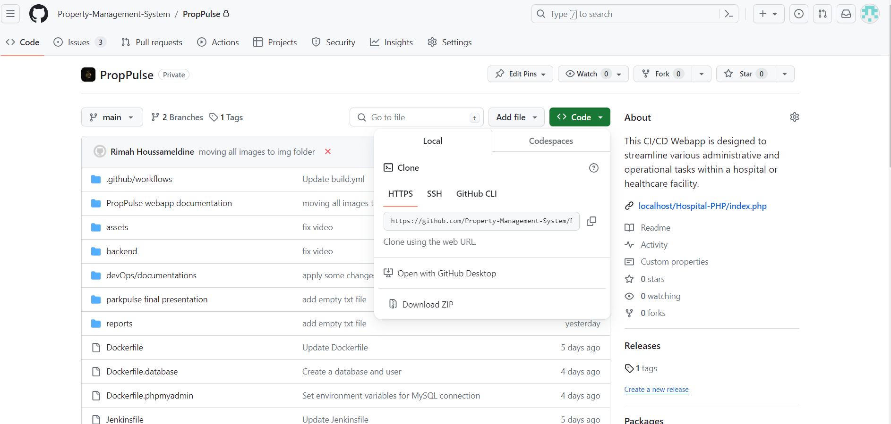



### Set up database

Setting up a database is a crucial step in organizing and managing data effectively. Whether you're a small business, a large corporation, or an individual with data to organize, a well-structured database can streamline processes and improve efficiency.

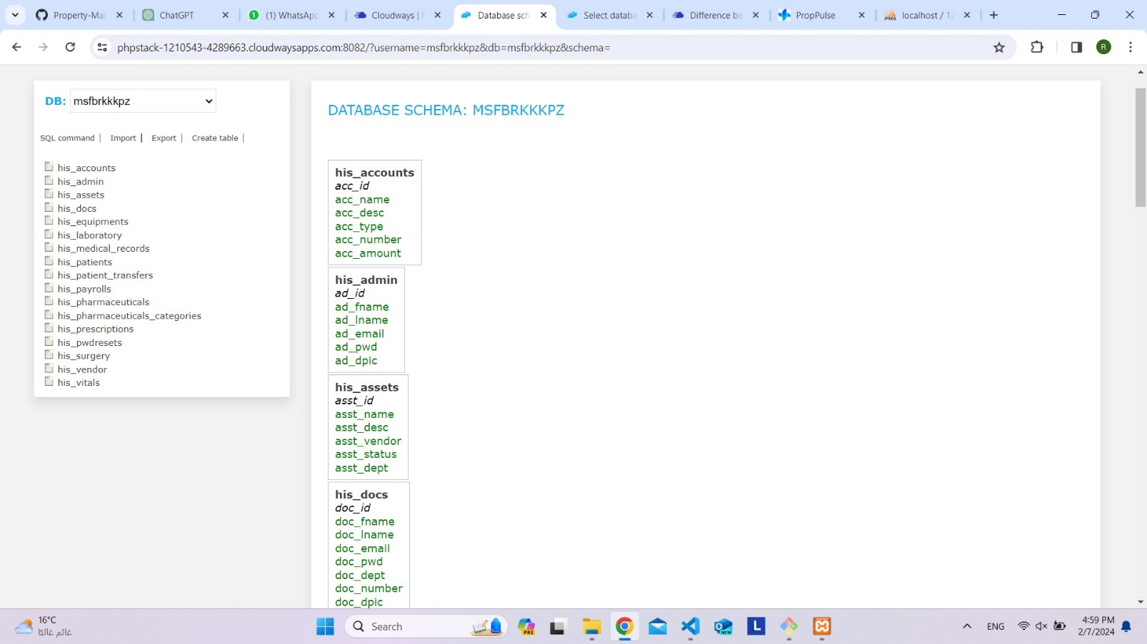

### Deploy Code from Your Repository

1. Go back to Cloudways console. Paste the SSH address you got in **Step 4** into the **Git Remote Address** ” field.
2. Select the branch of your repository you want to deploy from. In this example, we are using the master ” branch.
3. Type the deployment path (i.e. the folder in your server where the code will be deployed). Make sure to end it with a backslash (/). If you will leave this field empty, the code will be deployed to public_html/.
4. Click on the **Start Deployment** button to deploy your code to the selected path.

You will get a notification once the deployment process finishes.

You have further options to **delete** the repository from the server (no files will be deleted, see FAQ below). **Pull** the latest changes or **change** the branch you deploy from.

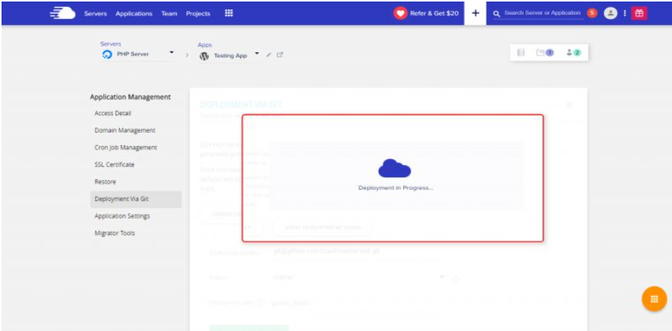

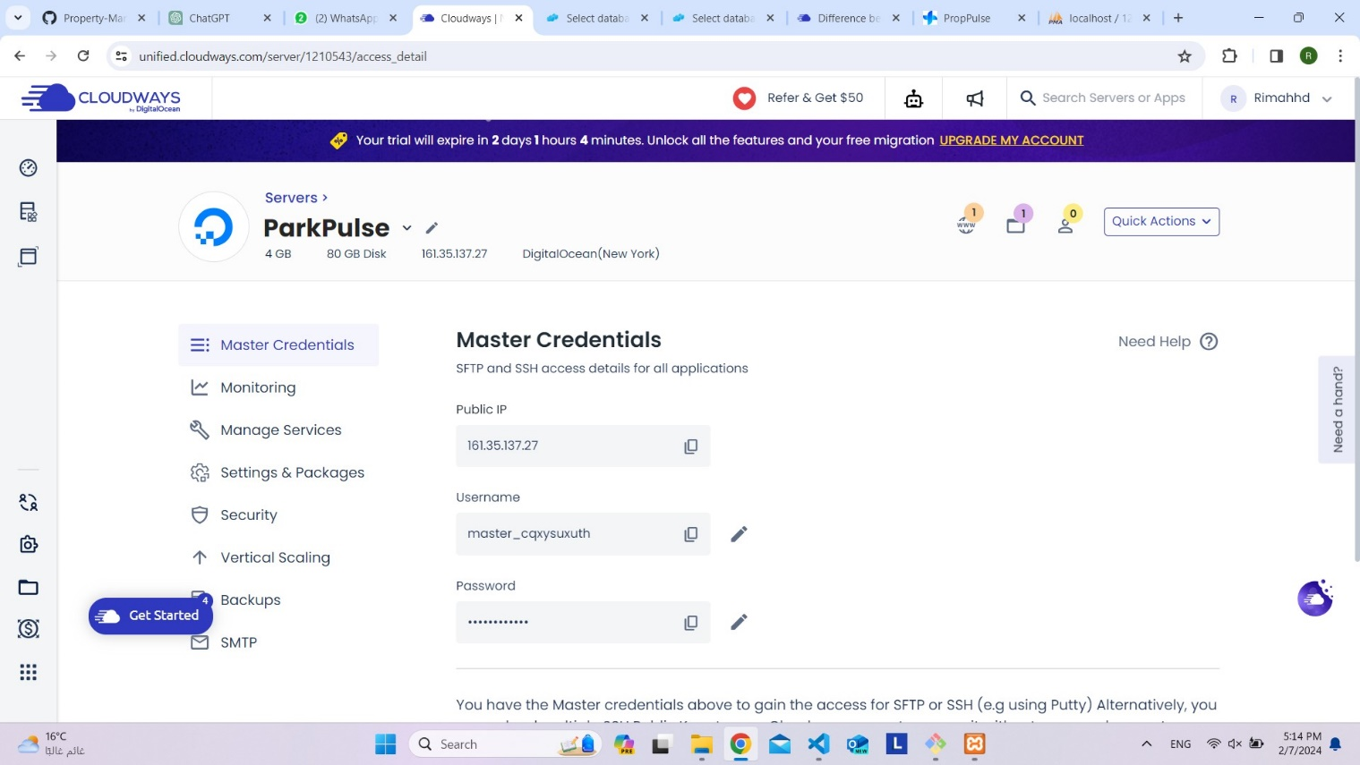



### The Server Monitor

The server monitor is a vigilant guardian of digital infrastructure, constantly monitoring the complex network of data flow and system performance. With its acute eye and analytical acumen, it identifies even little fluctuations in server health, alerting managers to possible problems before they become disasters. It guarantees optimal performance and prevents downtime by continuously monitoring and analyzing parameters such as CPU usage, memory consumption, disk I/O, and network traffic.

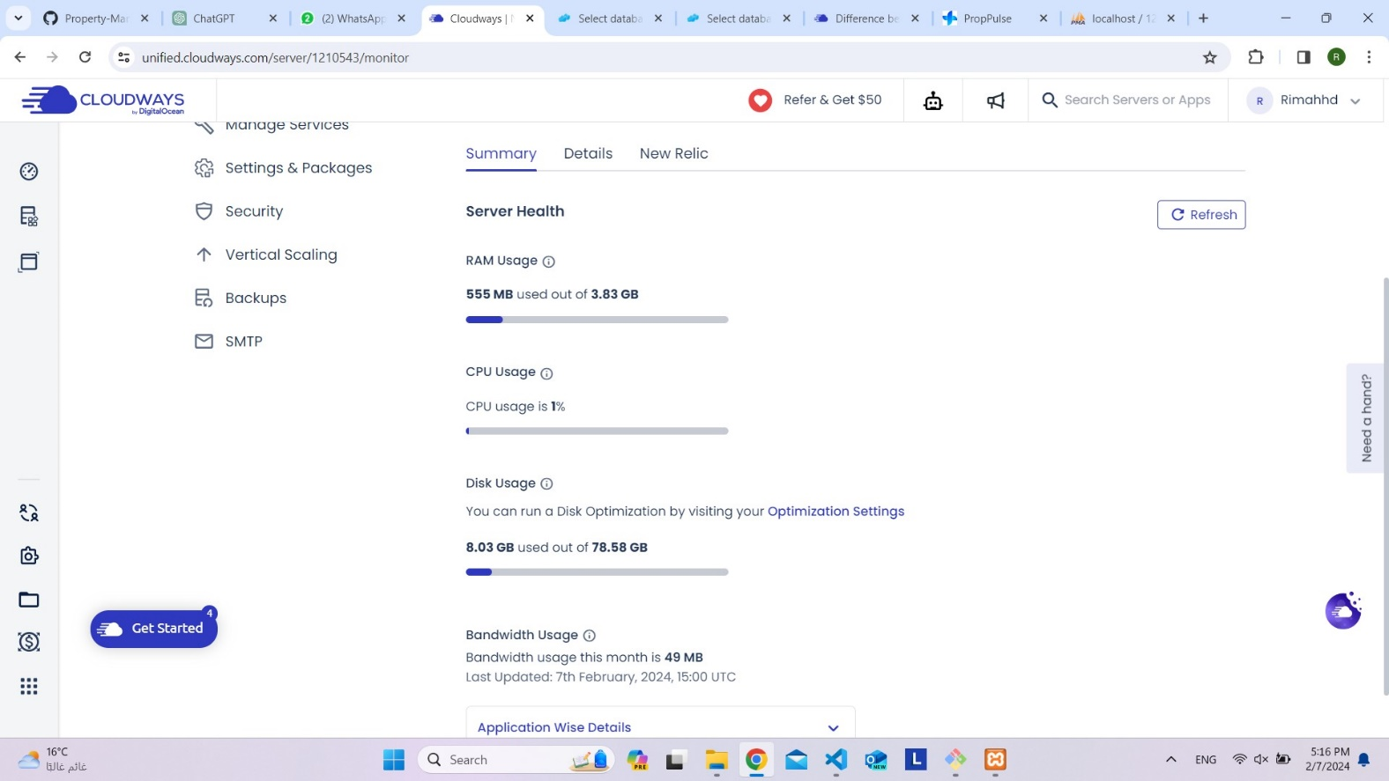

### Monitors on Websites and Their Logs

Uptime Monitors, Performance Monitors, Security Monitors, Content Monitors, Traffic Monitors, Error Monitors.

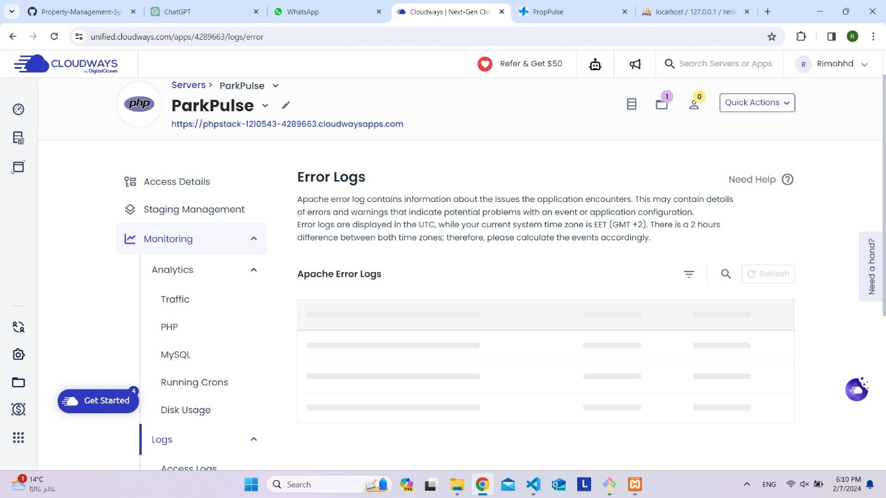

# Conclusion

In conclusion, deploying PHP applications with automation tools like GitHub and Cloudways offers a streamlined and efficient workflow for developers. By leveraging version control with GitHub and the robust deployment features of Cloudways, developers can automate the deployment process, ensuring consistency, reliability, and scalability. This integration simplifies the deployment pipeline, reduces manual intervention, and facilitates rapid iteration and updates. Ultimately, embracing automation tools enhances productivity, accelerates time-to-market, and promotes seamless collaboration among development teams.